Jacob Cannamela

Scott Hackett

Cindy Hernandez

Colton Kohler

CSD310

12/13/2024

**Milestone 4 assignment**

We are Group #4, comprised of Jacob Cannamela, Scott Hackett, Cindy Hernandez, and Colton Kohler. Each of us is pursuing a bachelor’s degree in software engineering while balancing the responsibilities of family life. For our Database Development and Use class, CSD310, we have chosen the Outland Adventures Case Study as the focus of our group project. Together, we are committed to delivering a thoughtful and well-executed solution by combining our diverse perspectives and collaborative efforts.

Outland Adventures is a small business founded by outdoor enthusiasts Blythe Timmerson and Jim Ford, who provide guided hiking and camping trips along with equipment rentals and sales. The organization is at a pivotal moment, seeking to optimize its operations by analyzing customer trends, inventory management, and sales data to ensure long-term success. Our project will focus on designing and implementing a database solution to address these operational challenges, combining our skills to deliver an effective system.

Below is the finalized ERD for our database layout. We believe this ERD represents a complete and full database to meet all the requirements of our case study.

We decided the 3 reports we wanted to produce were:

1. Trip Booking Status Report.
   1. This report shows us which customers have / have not paid yet

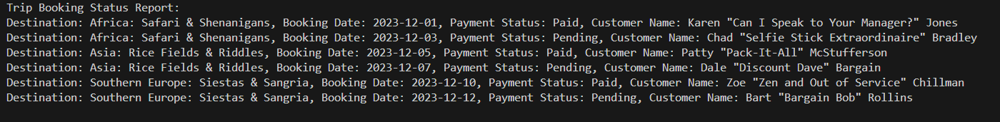

1. Equipment Availability Report.
   1. This report easily lets us see what equipment is still available

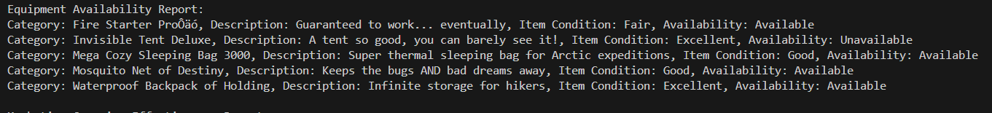

1. Marketing Campaign Effectiveness Report:
   1. This report lets us see which trips are in high demand



**Assumptions:**

* We assumed the trips demand levels were in high demand
* We assumed the equipment availability
* We assumed the customer payment status